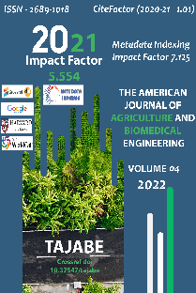
Research Article

BIOECOLOGY AND HARM OF THE COMSTOCK WORM (PSEUDOCOCCUS COMSTOCKI KUWANA 1902)

Submission Date: May 10, 2022, Accepted Date: May 20, 2022,
Published Date: May 30, 2022 |
Crossref doi: https://doi.org/10.37547/tajabe/Volume04Issue05-08

Bakojon Murodov
Candidate of Biological Sciences, Associate Professor, Research Institute of Quarantine and Plant Protection, Uzbekistan

Mashrabjon Shaymanov
PhD base doctoral student, Research Institute of Quarantine and Plant Protection, Uzbekistan

Journal Website: https://theamericanjournals.com/index.php/tajabe
Copyright: Original content from this work may be used under the terms of the creative commons attributes 4.0 licence.

ABSTRACT
The Comstock worm is native to Japan and China, and entomologist S. Kuwan described the worm in 1902 and named it Comstock in honor of the American entomologist Comstoc. The Comstock worm has not been reported in the literature for many years, and by the 1920s, reports of new outbreaks had begun to appear in the press. Comstock worms are now found in many countries in Asia, Africa, Australia, the Americas and Europe. Comstock worms are widespread in all Central Asian republics, including Kazakhstan, Georgia, Armenia, Azerbaijan and Uzbekistan.

KEYWORDS
Bioecology, taxonomic systematics, damage, morphology, agrotechnical control measures, biological control measures, chemical control measures.

INTRODUCTION

The Comstock worm was first detected in Uzbekistan in August 1939 at the Central Asian Silk Institute's Jararik Experimental Farm near Tashkent in large-leaved mulberry seedlings imported from Japan. In Uzbekistan, comstock worms have spread throughout the irrigated part of the Tashkent region, and then spread to other regions of the country. In the Fergana region, a comstock worm was found in 1947. The spread of worms here was faster than in Tashkent region. In 1953, the Comstock worm spread throughout the Fergana region. The abundance of orchards, trees, mulberry groves, and ditches helped the worms to spread quickly.
From 1953 to 1957, comstock worms spread very rapidly in all districts of Andijan region. The pest spread in 1957 in Zaamin, Jizzakh region, Ishtikhan district and Samarkand city of Samarkand region, in 1960 in Bukhara, Navoi regions and in 1961 in Surkhandarya region bordering Afghanistan. It appeared in Khorezm region in 1962, in the territory of the Republic of Karakalpakstan in 1964. In recent years, Comstock worms have been spreading throughout Uzbekistan. The pest is spreading to other areas through agricultural products and seedlings.
As of January 1, 2021, the Comstock worms of the Agency of the Republic of Uzbekistan for Plant Quarantine and Protection spread to a total of 955.55 hectares.
Taxonomic taxonomy:
• Domain: Eukaryota
• Kingdom: Metazoa
• Phylum: Arthropoda
• Subphylum: Uniramia
• Class: Insecta
• Order: Hemiptera
• Suborder: Sternorrhyncha
• Unknown: Coccoidea
• Family: Pseudococcidae
• Genus: Pseudococcus
• Species: Pseudococcus comstocki
Harm: Comstock worms infect 300 different plants. Pomegranate, bexi, apple, pear, peach, as well as mulberries from fruit trees cause severe damage. They settle in large colonies on the trunk, branches and leaves of the tree and absorb the sap of the tree, drying out its medicine and weakening its growth. In severely damaged trees, swellings appear, young branches dry out and the leaves fall off. Comstock worms penetrate the soil to a depth of 5–6 cm, damaging the flowers, fruits of the plant, and also sucked the upper part of the roots. Occurs in some cases at a depth of up to 40 cm. The worms usually feed along the veins in the lower part of the leaf. Comstock worms cause great damage to mulberry trees. Damaged mulberry leaves turn yellow and fall off into a haze. Mulberry leaves contaminated with Comstock worm waste are considered harmful to silkworms. A cup of pomegranate fruit is useful in the good development of the comstock worm and its eggs and drastically reduces the yield.
Morphology: Males and females differ sharply in appearance. The female is flat-shaped, wingless, less mobile, and 5 mm long, covered with white waxy spots. On the side of the body there are 17 pairs of waxy protrusions, the tail part being considerably elongated. The mustache has eight joints. The male of the Comstock worm has 1 pair of transparent wings, agile, reddish-brown in color, 1-1.5 mm long, with 10 joints of whiskers. The egg is 0.3 mm long, oval in shape, tapered on one side. The color is yellow-orange, covered with a thin white powder.

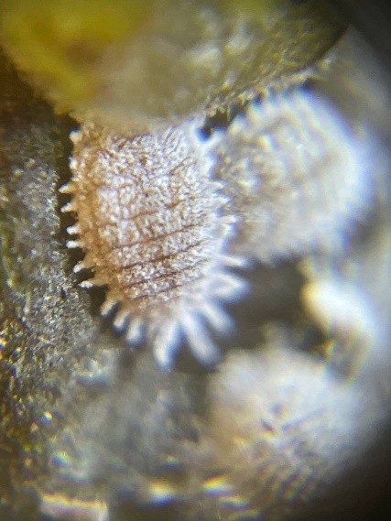 | 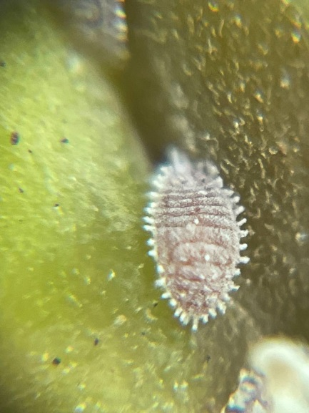 | 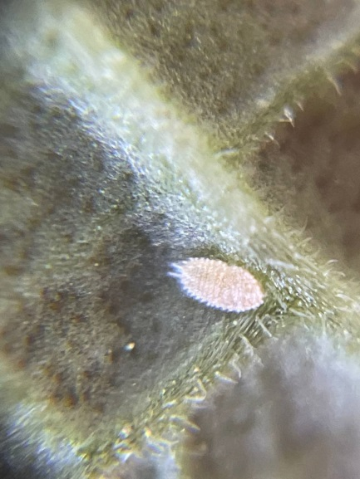

Pseudococcus comstocki Kuwana

Bioecology: In Uzbekistan, comstock worms reproduce three times a year, and partly for the fourth time. But with the fall of the cold, the fourth generation perishes. Comstock worms overwinter in the egg stage. One female worm lays 250 to 600 yellowish-orange eggs in a waxy white pouch. This sac is made by the female worm's wax-secreting glands. The third generation lays eggs for the winter in September-December. These waxy pockets are stiffer and denser than their predecessors. The development of one generation lasts from 42 to 65 days, depending on the temperature. The eggs are laid at a depth of 5 cm to 16 cm in the soil and rarely at a depth of 30 to 40 cm. Wintering eggs are very resistant to frost. Comstock worms are also common in countries with temperatures down to -300C (Pennsylvania, Ohio, Indiana, USA). Typically, comstock worms also accumulate in October and November in trees and near them in the form of two eggs in the active phase. With the onset of cold, worms and females are completely killed. All the eggs laid for the winter are destroyed. Only when winter comes well and it is warm will the comstock worm eggs in nature survive 5-15 percent. Therefore, the first generation of the comstock worm is usually very small. The period of worm emergence from the overwintered egg coincides with the time of mulberry emergence and the appearance of the first leaves, ie approximately the end of March and the beginning of April. The larvae that hatch from the eggs stay in the waxy pouch for the first 2-3 days, then crawl and crawl under the leaves and veins. Temperature and humidity are the main factors influencing the development of comstock worms.
Agrotechnical control measures: Dried branches of fruit and ornamental trees are cut, damaged branches are removed, trees are cleaned of old bark. The body of the plant is cleaned in the early spring using a stiff brush. Weeds are removed, and between the rows of trees, around the stems, agro-technical fruit and ornamental cultivation is carried out. Tree species and varieties suitable for certain soil-climatic conditions are selected. It is recommended to plant resistant varieties in areas where there is a risk of strong spread and development of the pest. Before planting seedlings, the soil should be enriched with mineral fertilizers and prepared in accordance with agronomic rules.
Biological control measures: In nature, 3 parasitic entomophages of comstock worms have been identified. Psevdafikus - Pseudaphycus malinus Gah. The developmental period of the pseudophycus and the host coincides at the same time. Adult larvae overwinter, in the mummy of comstock worms, which overwinter in cracks in the bark and in the soil. In the spring, when the air temperature averages 15 ° C, mature breeds begin to fly, and the females lay eggs inside the bodies of all the young of the host insect larvae. One female pseudoficus lays an average of 75-150 eggs.
Afelinus - Aphelinus mali In the gardens where Afelinus was applied, the number of pest worms was reduced to 80-98%. The female parasite lays 1, sometimes more, eggs on the body of the prey. Parasitic larvae emerge from their eggs in 3–4 days and feed on the internal presence of the worm larvae.
Chemical control measures: As a chemical control against Comstock worms it is advisable to use drugs containing the active ingredient Imidacloprid (imidacloprid), Dimethoate (dimethoate), Clotianidine (clothianidine), Lyambda-cygalotrin (lambda-cyhalothrin), Malation (malathion).
REFERENCES
- Архангельская А.Д. К фауне червецов и щитовок (Coccidae) Туркестана// труды Туркестанского научного общества, т.1. – Ташкент – 1923 – С 159-226.
- Атанов Н., Гуммель Э. - Ацекол против восточной плодожорки // Сельское хозяйство Узбекистана. – 1987. №3. - С.42-43.
- Кимсанбоев Х.Х. ва бошқ. «Ўсимликларни кимёвий ҳимоя қилиш». Тошкент, «Ўқитувчи», 1997.
- Муродов С.А. «Умумий энтомология» Тошкент. 1987.
- Муродов Б.Э., Яхёев Ж.Н. “Карантинный вредители внутреннего карантина Республики Узбекистан” Журнал, “Образование и наука в России и за зарубежом” 2017-й, №3(32), 32-36 с.
- Муродов Б.Э., Сулаймонов О.А., Яхёев Ж.Н. “Ўзбекистон Республикасида чегараланган ҳолда тарқалган ва четдан кириб келиши хавфи бўлган карантин зараркунандалар” услубий қўлланма Тошкент – 2017.
- Муҳаммадиев Б.Қ., Муродов Б.Э., Сулаймонов О.А.. “Pseudaphicus maculipenis-псевдофикусни лаборатория шароитида кўпайтириш бўйича қўлланма” Тошкент - 2012
- Шералиев А., Ўлмасбоева Р.Ш. “Қишлоқ хўжалик ўсимликларининг карантини”. Ўқитувчи 2008.
- Яхонтов В.В. «Ўрта Осиё қишлоқ хўжалик ўсимликлари ҳамда маҳсулотларини зараркунандалари ва уларга қарши кураш». «Тошкент» 1961.
- B.E.Murodov, J.N.Yakhyoyev QUARANTINE PESTS OF INTERNAL QUARANTINE OF THE REPUBLIC OF UZBEKISTAN // Education and science in Russia and abroad. – 2017. 3. – C. 32-33.
- M.Sh.Shaymanov, B.E.Murodov, J.N.Yakhyoyev PEST RISK ANALYSIS IN COMSTOCK MEALYBUG (PSEUDOCOCCUS COMSTOCKI) IN POMEGRANATE AND DATES // The American Journal of Agriculture and Biomedical Engineering (ISSN – 2689-1018) VOLUME 04. ISSUE 02. Pages: 12-16.

